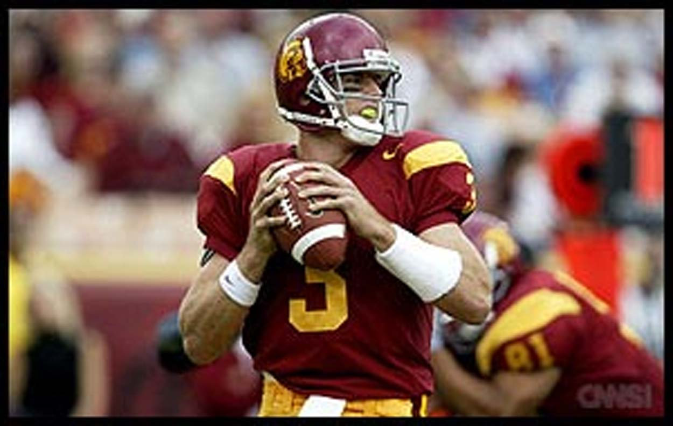
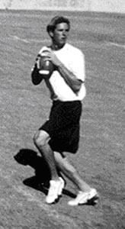
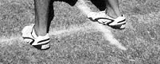
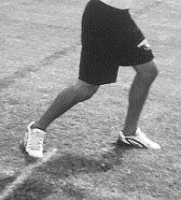
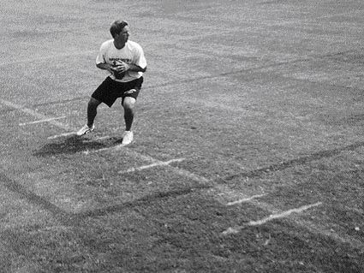
1 - Ball Carriage
Holding the ball correctly on the dropback helps keep the movement smooth and efficient and will actually improve the rotation of the football. Here, Carson Palmer does a great job of carrying the ball in a
relaxed and efficient manner.
2 - Shoulders on Dropback
The shoulders should be slightly open to the field with the facemask down the middle of the field. This allows the quarterback full vision of the field and does not allow the defense to see where he is going with the football.
3 - Plant-foot
The back (plant-foot) should be perpendicular to the target area just as the quarterback is stepping into the throw. This greatly increases the accuracy of the throw.
5 - Target-step
The target step should be short and across an imaginary line just to the inside of the plant-step. This shorter step will keep the throwing motion quick, compact, and allow the athlete to use more of his legs and shoulders during the throwing motion, thereby increasing the accuracy and velocity of the trajectory.
4 - Forward Shoulder
The forward shoulder should be pointed at the
target area just before the quarterback steps into the throw. By waiting until the throw, the QB will hold the defense and not allow them to read where the ball is going. Pointing the front shoulder to the
target area increases the accuracy of the throw.
Top 10 Key Points of Quarterback Mechanics
by Ron Jenkins, M.S., M.A. • www.TopGunQBAcademy.com
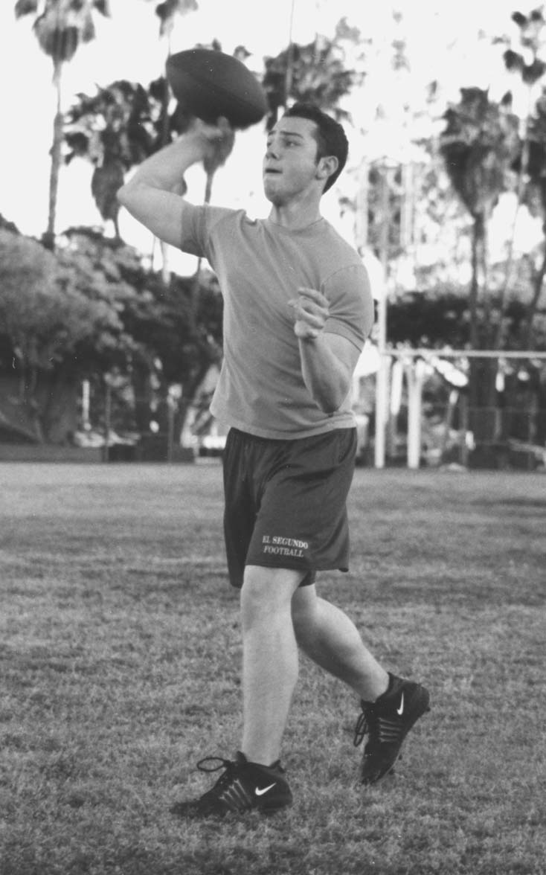
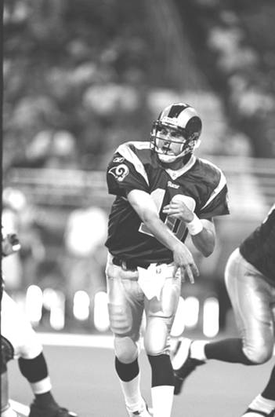
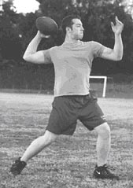
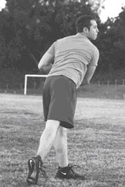
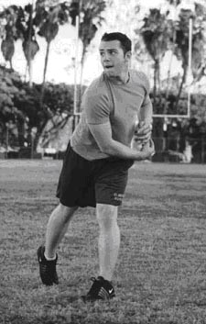
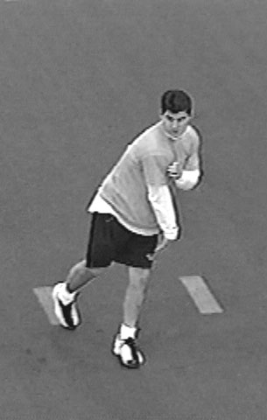
3 - Plant-foot
The back (plant-foot) should be perpendicular to the target area just as the quarterback is stepping into the throw. This greatly increases the accuracy of the throw.
5 - Target-step
The target step should be short and across an imaginary line just to the inside of the plant-step. This shorter step will keep the throwing motion quick, compact, and allow the athlete to use more of his legs and shoulders during the throwing motion, thereby increasing the accuracy and velocity of the trajectory.
6 - Throwing Elbow

7 - Vertical Head
8 - Throwing Hand
9 - Throwing Shoulder
10 - Trail Foot
During the throwing motion, keep the throwing elbow at, or above the throwing shoulder.
The head should be kept as vertical as possible throughout all throws.
The throwing hand should pronate (palm down) during the end of the motion, and should end up at the
opposite front pocket area. This is Marc Bolger of the N.F.L.’s St. Louis Rams. Marc also does a great job of using the shoulder-spin to get more rotation and velocity on the ball (see-below).
The throwing shoulder should end up pointing at the target area after the throw (shoulder-spin). This produces results immediately, and increases the
rotation of the football.
The trail foot should stay close to the ground throughout the throw, and end up even with the
target step after the throw.
1 - Ball Carriage
Holding the ball correctly on the dropback helps keep the movement smooth and efficient and will actually improve the rotation of the football. Here, Carson Palmer does a great job of carrying the ball in a
relaxed and efficient manner.
2 - Shoulders on Dropback
The shoulders should be slightly open to the field with the facemask down the middle of the field. This allows the quarterback full vision of the field and does not allow the defense to see where he is going with the football.
4 - Forward Shoulder
The forward shoulder should be pointed at the
target area just before the quarterback steps into the throw. By waiting until the throw, the QB will hold the defense and not allow them to read where the ball is going. Pointing the front shoulder to the
target area increases the accuracy of the throw.
Top 10 Key Points of Quarterback Mechanics
by Ron Jenkins, M.S., M.A. • www.TopGunQBAcademy.com

